Design patterns

Recurring solutions to common problems in software design.

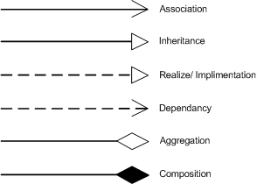

Creational patterns
These patterns have to do with class instantiation. They can be further divided into class-creation patterns and object-creational patterns. While class-creation patterns use inheritance effectively in the instantiation process, object-creation patterns use delegation to get the job done.
- Abstract Factory groups object factories that have a common theme.
- Builder constructs complex objects by separating construction and representation.
- Factory Method creates objects without specifying the exact object to create.
- Prototype creates objects by cloning an existing object.
- Singleton restricts object creation for a class to only one instance.

Structural patterns
Describes how classes and objects can be used to build large structures. The difference between class pattern and object pattern is that complex patter uses inheritance to build complex structure and Objects uses object composition to build large structure
- Adapter allows classes with incompatible interfaces to work together by wrapping its own interface around that of an already existing class.
- Bridge decouples an abstraction from its implementation so that the two can vary independently.
- Composite composes one-or-more similar objects so that they can be manipulated as one object.
- Decorator dynamically adds/overrides behavior in an existing method of an object.
- Facade provides a simplified interface to a large body of code.
- Flyweight reduces the cost of creating and manipulating a large number of similar objects.
- Proxy provides a placeholder for another object to control access, reduce cost, and reduce complexity.

Behavioral patterns
These design patterns are about Class's objects communication. They are specifically concerned with communication between objects.
- Chain of responsibility delegates commands to a chain of processing objects.
- Command creates objects which encapsulate actions and parameters.
- Interpreter implements a specialized language.
- Iterator accesses the elements of an object sequentially without exposing its underlying representation.
- Mediator allows loose coupling between classes by being the only class that has detailed knowledge of their methods.
- Memento provides the ability to restore an object to its previous state (undo).
- Observer is a publish/subscribe pattern which allows a number of observer objects to see an event.
- State allows an object to alter its behavior when its internal state changes.
- Strategy allows one of a family of algorithms to be selected on-the-fly at runtime.
- Template method defines the skeleton of an algorithm as an abstract class, allowing its subclasses to provide concrete behavior.
- Visitor separates an algorithm from an object structure by moving the hierarchy of methods into one object.
scope/Purpose | Creational | Structural | Behavioral
Class | Factory Method | Adapter | Interpreter
Class |  |  | Template Method
Object | Abstract Factory | Adapter | Chain of Responsibility
Object | Factory | Bridge | Command
Object | Builder | Composite | Iterator
Object | Prototype | Decorator | Mediator
Object | Singleton | Facade | Memento
Object |  | Flyweight | Observer
Object |  | Proxy | State
Object |  |  | Strategy
Object |  |  | Visitor

Factory Pattern
Consider as an example a program to read image files and make thumbnails out of them. The program supports different image formats, represented by a reader class for each format:
public interface ImageReader {
public DecodedImage getDecodedImage();
}

public class GifReader implements ImageReader {
public GifReader( InputStream in ) {
// check that it's a gif, throw exception if it's not, then if it is
// decode it.
}

public DecodedImage getDecodedImage() {
return decodedImage;
}
}

public class JpegReader implements ImageReader {
//....
}

Each time the program reads an image it needs to create a reader of the appropriate type based on some information in the file. This logic can be encapsulated in a factory method:
public class ImageReaderFactory {
public static ImageReader getImageReader( InputStream is ) {
int imageType = figureOutImageType( is );

switch( imageType ) {
case ImageReaderFactory.GIF:
return new GifReader( is );
case ImageReaderFactory.JPEG:
return new JpegReader( is );
// etc.
}
}
}

Abstract Factory Pattern
Abstract factory is a factory object that returns one of several Factories.

This insulates client code from object creation by having clients ask a factory object to create an object of the desired abstract type and to return an abstract pointer to the object

The class diagram of this design pattern is as shown below:
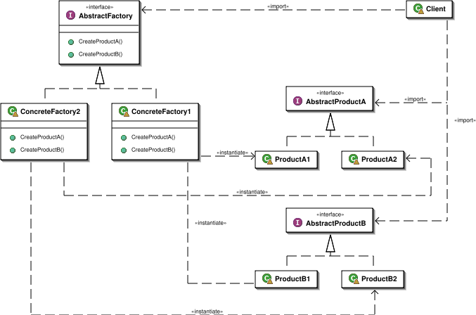

Examples
/*
* GUIFactory example
*/
abstract class GUIFactory
{
public static GUIFactory getFactory()
{
int sys = readFromConfigFile("OS_TYPE");
if (sys == 0)
{
return new WinFactory();
}
else
{
return new OSXFactory();
}
}

public abstract Button createButton();
}

class WinFactory extends GUIFactory
{
public Button createButton()
{
return new WinButton();
}
}

class OSXFactory extends GUIFactory
{
public Button createButton()
{
return new OSXButton();
}
}

abstract class Button
{
public abstract void paint();
}

class WinButton extends Button
{
public void paint()
{
System.out.println("I'm a WinButton: ");
}
}

class OSXButton extends Button
{
public void paint()
{
System.out.println("I'm an OSXButton: ");
}
}

public class Application
{
public static void main(String[] args)
{
GUIFactory factory = GUIFactory.getFactory();
Button button = factory.createButton();
button.paint();
}
// Output is either:
// "I'm a WinButton:"
// or:
// "I'm an OSXButton:"
}

Builder Pattern
The intention is to separate the construction of a complex object from its representation so that the same construction process can create different representations.

Class Diagram
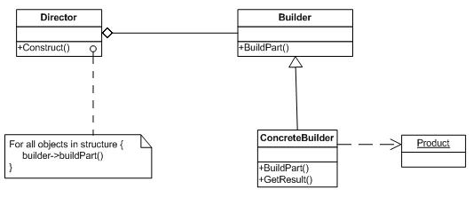
Ex:
For example, you can consider construction of a home. Home is the final end product (object) that is to be returned as the output of the construction process. It will have many steps, like basement construction, wall construction and so on roof construction. Finally the whole home object is returned. Here using the same process you can build houses with different properties.

Prototype Pattern
The Prototype pattern is used when creating an instance of a class is very time-consuming or complex in some way. Then, rather than creating more instances, you make copies of the original instance, modifying them as appropriate. Prototypes can also be used whenever you need classes that differ only in the type of processing they offer i.e. when there are many subclasses that differ only in the kind of objects they create a Prototype Pattern can be used to reduce the number of subclasses by cloning a prototype.

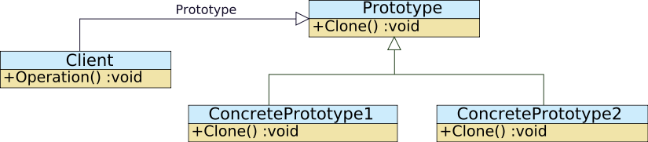
Ex:
Example assumptions:
- An e-commerce application gathers product information trough complex queries against a legacy database.
- The legacy database is updated at predefined intervals which are known.
- The number of products allows caching with a reasonable memory consumption.
When a user asks for information for a certain product the application could gather that information in two ways:
- execute the complex query against legacy database, gather the information, and instantiate the object.
- instantiate the objects at predefined intervals and keep them in a cache, when an object is requested, it is retrieved from cache and cloned. When the legacy database is updated, discard the content of the cache and re-load with new objects.

Singleton Pattern
The singleton pattern is a design pattern that is used to restrict instantiation of a class to one object. This is useful when exactly one object is needed to coordinate actions across the system

Ex:
Class SingleTon
{
private static uniqueInstance = null;
private SignleTon()
{
}

public SingleTon getInstance()
{
if (uniqueInstance ==null)
uniqueInstance = new SingleTon();
return uniqueInstance;

}
}

}
Math class is a final class in java with all static methods.

Object Pool Pattern

object pool is a set of initialised objects that are kept ready to use, rather than allocated and destroyed on demand. A client of the pool will request an object from the pool and perform operations on the returned object. When the client has finished with an object, it returns it to the pool, rather than destroying it. It is a specific type of factory object.

Structural Patterns
Structural patterns describe how classes and objects can be combined to form larger structures. The difference between class patterns and object patterns is that class patterns describe how inheritance can be used to provide more useful program interfaces. Object patterns, on the other hand, describe how objects can be composed into larger structures using object composition, or the inclusion of objects within other objects

Adapter Pattern
We use adapters whenever we want unrelated classes to work together in a single program. The concept of an adapter is thus pretty simple; we write a class that has the desired interface and then make it communicate with the class that has a different interface.

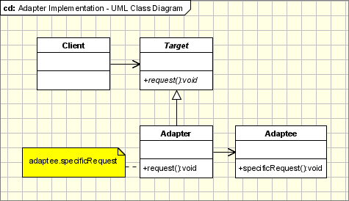

The adapter pattern is useful in situations where an already existing class provides some or all of the services you need but does not use the interface you need. A good real life example is an adapter that converts the interface of a Document Object Model of an XML document into a tree structure that can be displayed. A link to a tutorial that uses the adapter design pattern is listed in the links below.
Ex:
We have used some library where we have Add function which takes two integer and provides the sum of them. Now when upgrading the libray we find that the library has changed the Add function such that it takes 2 floating point number. Now one option could be to change all the client code where we have used the Add method or other option is to have an Adapter.

Sample - Class Adapter
/**
* Java code sample
*/

interface Stack
{
void push (Object o);
Object pop ();
Object top ();
}

/* DoubleLinkedList */
class DList
{
public void insert (DNode pos, Object o) { ... }
public void remove (DNode pos) { ... }

public void insertHead (Object o) { ... }
public void insertTail (Object o) { ... }

public Object removeHead () { ... }
public Object removeTail () { ... }

public Object getHead () { ... }
public Object getTail () { ... }
}

/* Adapt DList class to Stack interface */
class DListImpStack extends DList implements Stack
{
public void push (Object o) {
insertTail (o);
}

public Object pop () {
return removeTail ();
}

public Object top () {
return getTail ();
}
}

Composite Pattern
Composite allows a group of objects to be treated in the same way as a single instance of an object. When dealing with tree-structured data, programmers often have to discriminate between a leaf-node and a branch. This makes code more complex, and therefore, error prone.

Structure
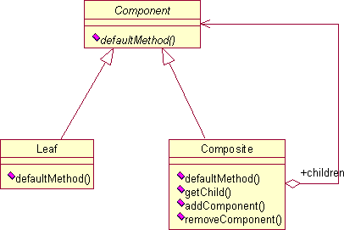
Component
- is the abstraction for all components, including composite ones
- declares the interface for objects in the composition
- implements default behavior for the interface common to all classes, as appropriate
- declares an interface for accessing and managing its child components
- (optional) defines an interface for accessing a components's parent in the recursive structure, and implements it if that's appropriate
Leaf
- represents leaf objects in the composition
- implements all Component methods
Composite
- represents a composite Component (component having children)
- implements methods to manipulate children
- implements all Component methods, generally by delegating them to its children

Example
The most common example in this pattern is of a company’s employee hierarchy. We here will also take the same example.
The employees of a company are at various positions. Now, say in a hierarchy, the manager has subordinates; also the Project Leader has subordinates, i.e. employees reporting to him/her. The developer has no subordinates.
So, let’s have a look at the class Employee: This is a simple class with getters and setters for attributes as name, salary and subordinates.
Employee.java
package structural.composite;
import java.util.Vector;
public class Employee {
private String name;
private double salary;
private Vector subordinates;
public Vector getSubordinates() {
return subordinates;
}
public void setSubordinates(Vector subordinates) {
this.subordinates = subordinates;
}
// constructor
public Employee(String name, double sal) {
setName(name);
setSalary(sal);
subordinates = new Vector();
}
public String getName() {
return name;
}
public void setName(String name) {
this.name = name;
}
public double getSalary() {
return salary;
}
public void setSalary(double salary) {
this.salary = salary;
}
public void add(Employee e) {
subordinates.addElement(e);
}
public void remove(Employee e) {
subordinates.remove(e);
}
}// End of interface
Next we, fill up the tree. You can make a class to access the class Employee and try filling up the tree like this:
/**
* This will add employess to the tree. The boss, is PM
* and has subordinates.
*/
private void addEmployeesToTree() {
CFO = new Employee("CFO", 30000);
Employee headFinance1 = new Employee("Head Finance. North Zone", 20000);
Employee headFinance2 = new Employee("Head Finance. West Zone", 22000);
Employee accountant1 = new Employee("Accountant1", 10000);
Employee accountant2 = new Employee("Accountant2", 9000);
Employee accountant3 = new Employee("Accountant3", 11000);
Employee accountant4 = new Employee("Accountant4", 12000);
CFO.add(headFinance1);
CFO.add(headFinance2);
headFinance1.add(accountant1);
headFinance1.add(accountant4);
headFinance2.add(accountant2);
headFinance2.add(accountant3);
}// End of class
Once we have filled the tree up, now we can get the tree for any employee and find out whether that employee has subordinates with the following condition.
Vector subOrdinates = emp.getSubordinates();
if (subOrdinates.size() != 0)
getTree(subOrdinates);
else
System.out.println("No Subordinates for the Employee: "+emp.getName());
Thus the Composite pattern allows you to create a tree like structure for simple and complex objects so they appear the same to the client.

Bridge Pattern
Decouple an abstraction from its implementation so that the two can vary independently.

Implementation
The figure below shows a UML class diagram for the Bridge Pattern:
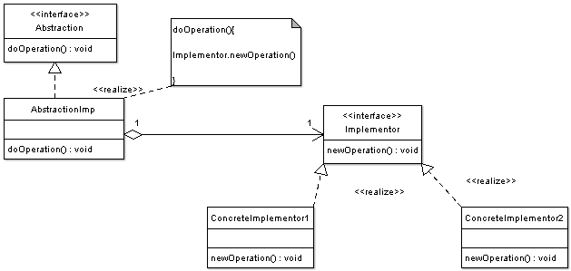

Ex:

Sometimes an abstraction should have different implementations; consider an object that handles persistence of objects over different platforms using either relational databases or file system structures (files and folders). A simple implementation might choose to extend the object itself to implement the functionality for both file system and RDBMS. However this implementation would create a problem; Inheritance binds an implementation to the abstraction and thus it would be difficult to modify, extend, and reuse abstraction and implementation independently.

Java Source Code Example for the Bridge Design Pattern - Object Persistence API
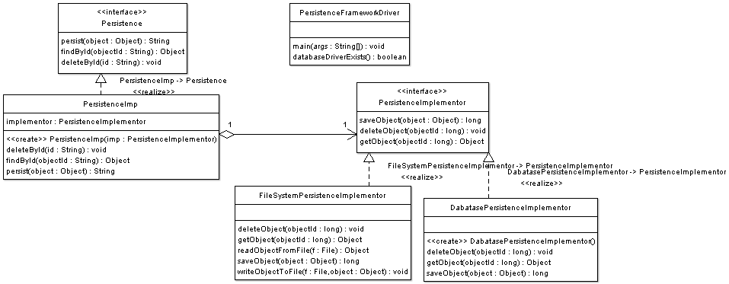
We consider the case of a persistence API can have many implementations depending on the presence or absence of a relational database, a file system, as well as on the underlying operating system.
The code below illustrates the Abstraction interface
package bridge;

/**
* Persistence Interface
* Abstraction Interface
*/
public interface Persistence {

/**
* @param object
* @return returns objectID
*/
public String persist(Object object);

/**
*
* @param objectId
* @return persisted Object
*/
public Object findById(String objectId);

/**
*
* @param id
*/
public void deleteById(String id);

}
The code below illustrates the Abstraction Imp:
package bridge;

/**
* Abstraction Imp
*/
public class PersistenceImp implements Persistence {

private PersistenceImplementor implementor = null;

public PersistenceImp(PersistenceImplementor imp) {

this.implementor = imp;

}

@Override
public void deleteById(String id) {

implementor.deleteObject(Long.parseLong(id));

}

@Override
public Object findById(String objectId) {

return implementor.getObject(Long.parseLong(objectId));
}

@Override
public String persist(Object object) {

return Long.toString(implementor.saveObject(object));

}

}
The code below illustrates the Implementor interface
package bridge;

/**
* Implementor Interface
*/
public interface PersistenceImplementor {

public long saveObject(Object object);

public void deleteObject(long objectId);

public Object getObject(long objectId);

}
The code below illustrates file system concrete implementor:
/**
*
*/
package bridge;

import java.io.File;

/**
* Concrete Implementor
*
*/
public class FileSystemPersistenceImplementor implements PersistenceImplementor{

@Override
public void deleteObject(long objectId) {

File f = new File("/persistence/"+Long.toString(objectId));

f.delete();

return;
}

@Override
public Object getObject(long objectId) {

File f = new File("/persistence/"+Long.toString(objectId));

return readObjectFromFile(f);

}

private Object readObjectFromFile(File f) {

// open file
// and load object
//return the object
return null;
}

@Override
public long saveObject(Object object) {

long fileId = System.currentTimeMillis();

// open file
File f = new File("/persistence/"+Long.toString(fileId));

// write file to Streanm

writeObjectToFile(f,object);

return fileId;

}

private void writeObjectToFile(File f, Object object) {

// serialize object and write it to file

}

}
The code below illustrates the database concrete implementor.
package bridge;

public class DabatasePersistenceImplementor implements PersistenceImplementor{

public DabatasePersistenceImplementor() {

// load database driver

}

@Override
public void deleteObject(long objectId) {

// open database connection
// remove record

}

@Override
public Object getObject(long objectId) {

// open database connection
// read records
// create object from record
return null;
}

@Override
public long saveObject(Object object) {

// open database connection
// create records for fields inside the object

return 0;
}

}
The code below illustrates a persistence API driver, note how the choice of concrete implementor does not affect the client code , note also that extending persistence does not affect the implementor and extending the implementor does not extend the persistence.
package bridge;

public class PersistenceFrameworkDriver {

public static void main(String[] args) {

// this program needs a persistence framework
// at runtime an implementor is chosen between file system implementation and
//database implememtor , depending on existence of databse drivers

PersistenceImplementor implementor = null;

if(databaseDriverExists()){

implementor = new DabatasePersistenceImplementor();

}else{

implementor = new FileSystemPersistenceImplementor();
}

Persistence persistenceAPI = new PersistenceImp(implementor);

Object o = persistenceAPI.findById("12343755");

// do changes to the object

// then persist

persistenceAPI.persist(o);

// can also change implementor
persistenceAPI = new PersistenceImp(new DabatasePersistenceImplementor());

persistenceAPI.deleteById("2323");

}

private static boolean databaseDriverExists() {

return false;
}
}

Decorator Pattern

The decorator pattern applies when there is a need to dynamically add as well as remove responsibilities to a class, and when subclassing would be impossible due to the large number of subclasses that could result.

Implementation
The figure below shows a UML class diagram for the Decorator Pattern:
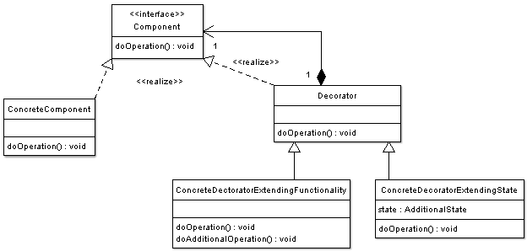The participants classes in the decorator pattern are:
- Component - Interface for objects that can have responsibilities added to them dynamically.
- ConcreteComponent - Defines an object to which additional responsibilities can be added.
- Decorator - Maintains a reference to a Component object and defines an interface that conforms to Component's interface.
- Concrete Decorators - Concrete Decorators extend the functionality of the component by adding state or adding behavior.

Ex:

Consider the typical example of a graphical window. To extend the functionality of the graphical window for example by adding a frame to the window, would require extending the window class to create a FramedWindow class. To create a framed window it is necessary to create an object of the FramedWindow class. However it would be impossible to start with a plain window and to extend its functionality at runtime to become a framed window.

Decorator Design Pattern is applied in Graphical User Interface toolkits to add dynamically windows behaviors.
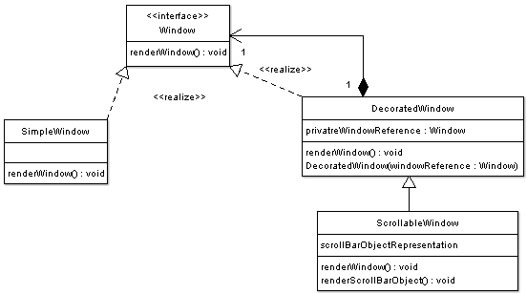

The code below illustrates the Window interface representing the component interface.
package decorator;

/**
* Window Interface
*
* Component window
*/
public interface Window {

public void renderWindow();

}
The code below illustrates concrete window implementation:
package decorator;

/**
* Window implementation
*
* Concrete implementation
*/
public class SimpleWindow implements Window {

@Override
public void renderWindow() {
// implementation of rendering details

}
}
The code below illustrates the basic decorated window implementation. Note that the decorator maintains a reference to a window object that is being decorated.
package decorator;

/**
*
*/
public class DecoratedWindow implements Window{

/**
* private reference to the window being decorated
*/
private Window privateWindowRefernce = null;

public DecoratedWindow( Window windowRefernce) {

this.privateWindowRefernce = windowRefernce;
}

@Override
public void renderWindow() {

privateWindowRefernce.renderWindow();

}
}
The code below illustrates a scrollable window which is a decorated window
package decorator;

/**
* Concrete Decorator with extended state
*
* Scrollable window creates a window that is scrollable
*
*
*/
public class ScrollableWindow extends DecoratedWindow{

/**
* Additional State
*/
private Object scrollBarObjectRepresentation = null;

public ScrollableWindow(Window windowRefernce) {

super(windowRefernce);
}

@Override
public void renderWindow() {

// render scroll bar
renderScrollBarObject();

// render decorated window
super.renderWindow();
}

private void renderScrollBarObject() {

// prepare scroll bar
scrollBarObjectRepresentation = new Object();

// render scrollbar

}
}
The code below illustrates a driver program for the window component. Note how the scrolling functionality has been added dynamically at runtime.
package decorator;

public class GUIDriver {

public static void main(String[] args) {

// create a new window

Window window = new ConcreteWindow();

window.renderWindow();

// at some point later
// maybe text size becomes larger than the window
// thus the scrolling behavior must be added

// decorate old window
window = new ScrollableWindow(window);

// now window object
// has additional behavior / state

window.renderWindow();

}
}

Façade Pattern
This pattern defines a higher-level interface that makes the subsystem easier to use.

Ex: Using database connection to get database meta data and resultset meta data information.

Flyweight Pattern
Flyweight is used when there is a need to create high number of objects of almost similar nature. High number of objects consumes high memory and flyweight design pattern gives a solution to reduce the load on memory by sharing objects.

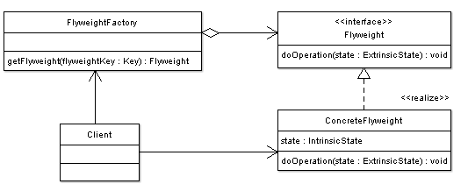
Ex:
Consider for example a game of war, were there is a large number of soldier objects; a soldier object maintain the graphical representation of a soldier, soldier behavior such as motion, and firing weapons, in addition soldier�s health and location on the war terrain. The solution is to keep the common state of soldiers in a shared object
The war game example instantiates 5 Soldier clients, each client maintains its internal state which is extrinsic to the soldier flyweight. And Although 5 clients have been instantiated only one flyweight Soldier has been used.
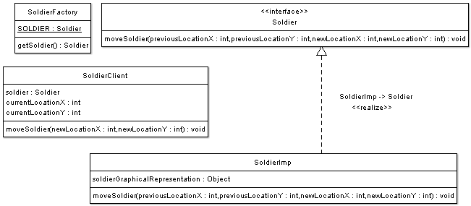
The code below shows Soldier interface which is the flyweight interface
package flyweight;

/**
* Flyweight Interface
*
*/
public interface Soldier {

/**
* Move Soldier From Old Location to New Location
* Note that soldier location is extrinsic
* to the SoldierFlyweight Implementation
* @param previousLocationX
* @param previousLocationY
* @param newLocationX
* @param newLocationY
*/
public void moveSoldier(int previousLocationX,
int previousLocationY , int newLocationX ,int newLocationY);
}
The code below shows the SoldierImp which is the flyweight implementation
package flyweight;

public class SoldierImp implements Soldier {

/**
* Intrinsic State maintained by flyweight implementation
* Solider Shape ( graphical represetation)
* how to display the soldier is up to the flyweight implementation
*/
private Object soldierGraphicalRepresentation;

/**
* Note that this method accepts soldier location
* Soldier Location is Extrinsic and no reference to previous location
* or new location is maintained inside the flyweight implementation
*/
public void moveSoldier(int previousLocationX, int previousLocationY,
int newLocationX, int newLocationY) {

// delete soldier representation from previous location
// then render soldier representation in new location
}
}
The code below shows the Soldier Factory from which we instantiate Soldiers Flyweight
package flyweight;

/**
* Flyweight Factory
*/
public class SoldierFactory {

/**
* Pool for one soldier only
* if there are more soldier types
* this can be an array or list or better a HashMap
*
*/
private static Soldier SOLDIER;

/**
* getFlyweight
* @return
*/
public static Soldier getSoldier(){

// this is a singleton
// if there is no soldier
if(SOLDIER==null){

// create the soldier
SOLDIER = new SoldierImp();
}

// return the only soldier reference
return SOLDIER;
}
}
The code below shows SoldierClient implementation. The client uses the Flyweight soldier reference to perform its tasks
package flyweight;

/**
* This is the "Heavyweight" soldier object
* which is the client of the flyweight soldier
* this object provides all soldier services and is used in the game
*/
public class SoldierClient {

/**
* Reference to the flyweight
*/
private Soldier soldier = SoldierFactory.getSoldier();

/**
* this state is maintained by the client
*/
private int currentLocationX = 0;

/**
* this state is maintained by the client
*/
private int currentLocationY=0;

public void moveSoldier(int newLocationX, int newLocationY){

// here the actual rendering is handled by the flyweight object
soldier.moveSoldier(currentLocationX,
currentLocationY, newLocationX, newLocationY);

// this object is responsible for maintaining the state
// that is extrinsic to the flyweight
currentLocationX = newLocationX;

currentLocationY = newLocationY;
}
}
The code below shows the war game implementation. Note that war game instantiates 5 Soldier clients, each client maintains its internal state which is extrinsic to the soldier flyweight. And Although 5 clients have been instantiated only one flyweight Soldier has been used.
package flyweight;

/**
* Driver : War Game
*/
public class WarGame {

public static void main(String[] args) {
// start war

// draw war terrain

// create 5 soldiers:
SoldierClient warSoldiers [] ={
new SoldierClient(),
new SoldierClient(),
new SoldierClient(),
new SoldierClient(),
new SoldierClient()
};

// move each soldier to his location
// take user input to move each soldier
warSoldiers[0].moveSoldier(17, 2112);

// take user input to move each soldier
warSoldiers[1].moveSoldier(137, 112);

// note that there is only one SoldierImp ( flyweight Imp)
// for all the 5 soldiers
// Soldier Client size is small due to the small state it maintains
// SoliderImp size might be large or might be small
// however we saved memory costs of creating 5 Soldier representations
}
}

Proxy Pattern

Proxy Pattern is used when you want to represent a complex object with a simpler one. This is used whenever creating an instance is a time consuming or resource intensive. Proxy delay the creation of the instance unless it is actually needed. It has same methods as that of the Actual Object, and once the actual object is loaded it passes the method call to actual object.

Proxy could be used when you want to lazy-instantiate an object, or hide the fact that you're calling a remote service, or control access to the object.

The figure below shows a UML class diagram for the Proxy Pattern:
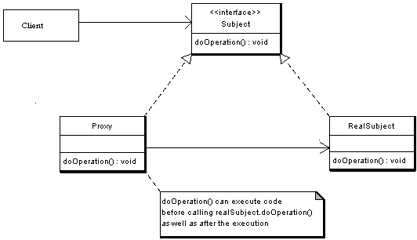
The participants classes in the proxy pattern are:
- Subject - Interface implemented by the RealSubject and representing its services. The interface must be implemented by the proxy as well so that the proxy can be used in any location where the RealSubject can be used.
- Proxy
  - Maintains a reference that allows the Proxy to access the RealSubject.
  - Implements the same interface implemented by the RealSubject so that the Proxy can be substituted for the RealSubject.
  - Controls access to the RealSubject and may be responsible for its creation and deletion.
  - Other responsibilities depend on the kind of proxy.
- RealSubject - the real object that the proxy represents.

Java RMI is based on Proxy pattern.

EX:
Consider an image viewer program that lists and displays high resolution photos. The program has to show a list of all photos however it does not need to display the actual photo until the user selects an image item from a list.
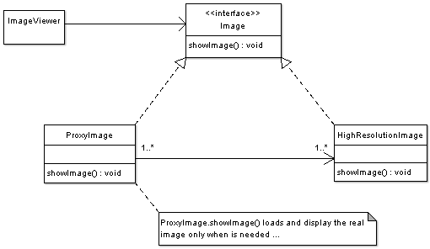
The code below shows the Image interface representing the Subject. The interface has a single method showImage() that the Concrete Images must implement to render an image to screen.
package proxy;

/**
* Subject Interface
*/
public interface Image {

public void showImage();

}

The code below shows the Proxy implementation, the image proxy is a virtual proxy that creates and loads the actual image object on demand, thus saving the cost of loading an image into memory until it needs to be rendered:
package proxy;

/**
* Proxy
*/
public class ImageProxy implements Image {

/**
* Private Proxy data
*/
private String imageFilePath;

/**
* Reference to RealSubject
*/
private Image proxifiedImage;

public ImageProxy(String imageFilePath) {
this.imageFilePath= imageFilePath;
}

@Override
public void showImage() {

// create the Image Object only when the image is required to be shown

proxifiedImage = new HighResolutionImage(imageFilePath);

// now call showImage on realSubject
proxifiedImage.showImage();

}

}

The code below displays the RealSubject Implementation, which is the concrete and heavyweight implementation of the image interface. The High resolution image, loads a high resolution image from disk, and renders it to screen when showImage() is called.
package proxy;

/**
* RealSubject
*/
public class HighResolutionImage implements Image {

public HighResolutionImage(String imageFilePath) {

loadImage(imageFilePath);
}

private void loadImage(String imageFilePath) {

// load Image from disk into memory
// this is heavy and costly operation
}

@Override
public void showImage() {

// Actual Image rendering logic

}

}

The code below illustrates a sample image viewer program; the program simply loads three images, and renders only one image, once using the proxy pattern, and another time directly. Note that when using the proxy pattern, although three images have been loaded, the High resolution image is not loaded into memory until it needs to be rendered, while in the part not using the proxy, the three images are loaded into memory although one of them is actually rendered.
package proxy;

/**
* Image Viewer program
*/
public class ImageViewer {

public static void main(String[] args) {

// assuming that the user selects a folder that has 3 images
//create the 3 images
Image highResolutionImage1 = new ImageProxy("sample/veryHighResPhoto1.jpeg");
Image highResolutionImage2 = new ImageProxy("sample/veryHighResPhoto2.jpeg");
Image highResolutionImage3 = new ImageProxy("sample/veryHighResPhoto3.jpeg");

// assume that the user clicks on Image one item in a list
// this would cause the program to call showImage() for that image only
// note that in this case only image one was loaded into memory
highResolutionImage1.showImage();

// consider using the high resolution image object directly
Image highResolutionImageNoProxy1 = new HighResolutionImage("sample/veryHighResPhoto1.jpeg");
Image highResolutionImageNoProxy2 = new HighResolutionImage("sample/veryHighResPhoto2.jpeg");
Image highResolutionImageBoProxy3 = new HighResolutionImage("sample/veryHighResPhoto3.jpeg");

// assume that the user selects image two item from images list
highResolutionImageNoProxy2.showImage();

// note that in this case all images have been loaded into memory
// and not all have been actually displayed
// this is a waste of memory resources

}

}

Behavioural Pattern
This type of pattern is concerned about the communication between the objects.

- Chain o Responsibility
chain-of-responsibility pattern is a design pattern consisting of a source of command objects and a series of processing objects. Each processing object contains a set of logic that describes the types of command objects that it can handle, and how to pass off those that it cannot handle to the next processing object in the chain

Ex: Java Logger.

State Pattern
This pattern is used to maintain the state of an object. The State pattern allows an object to change its behavior when its internal state changes.

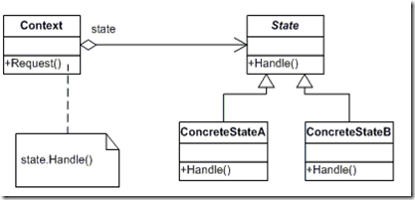

Ex:

package tips.pattern.state;
public class Person {
private String name;
private String character;

public Person(String name, String character) {
this.name = name;
this.character = character;
}

public void giveMeMoney() {
if (character.equals("GoodCharacter")) {
System.out.println("Yes, take all my money");
} else if (character.equals("BadCharacter")) {
System.out.println("No, I dont have anything with me");
} else if (character.equals("OtherCharacter")) {
System.out.println("I will give the money tmrw");
}
}
}
We have modeled a Person object passing his name and a string representing his character, which may be a Good Character or Bad Character or some Other Character. If someone comes to him and asks for money by calling the Person.giveMeMoney() method, his behavior is entirely dependant on his character. Technically, his behavior is tightly coupled with the internal variable character.
The above design has one great dis-advantage. Suppose we want to add further characters that represent some other different behavior of a Person, then we end up in adding if-else clauses, which certainly is not very good from a design perspective because of changes being done in the existing code.
So, how to provide support for different characteristic behaviors for a person without making code changes? Here comes the State pattern which just do that. The State pattern mandates to model behavior as interfaces rather than representing them as Strings or some other types. For example, since character is the changing behavior for a Person, let us encapsulate it by having something like the following,
Character.java
package tips.pattern.state;

public interface Character {
public void giveMeMoney();
}

See, we have modeled a person’s Character as an interface. Now, let us see the implementation for different characteristic feature of a person, say GoodCharacter and BadCharacter.
GoodCharacter.java
1  2  3  4  5  6  7  8 | package tips.pattern.state;  public class GoodCharacter implements Character {  @Override  public void giveMeMoney() {  System.out.println("Yes, take all my money");  }  }
BadCharacter.java
1  2  3  4  5  6  7  8 | package tips.pattern.state;  public class BadCharacter implements Character {  @Override  public void giveMeMoney() {  System.out.println("No, I dont have anything with me");  }  }
Now, let us see the new Person class which accepts character in the form of an interface rather than as a String. Given below is the code snippet for the same.
Person2.java
1  2  3  4  5  6  7  8  9  10  11  12  13  14  15  16  17  18  19  20  21  22 | package tips.pattern.state;  public class Person2 {  private String name;  private Character character;  public Person2(String name, Character character) {  this.name = name;  this.character = character;  }  public void giveMeMoney() {  character.giveMeMoney();  }  public static void main(String[] args) {  Person2 object = new Person2("John", new GoodCharacter());  object.giveMeMoney();  object = new Person2("John", new BadCharacter());  object.giveMeMoney();  }  }
Since now the character is represented as an interface, there wont be any more code changes if there is a need to add new characteristic behavior. All we need to do is to define the new character class implementing the Character interface.

Strategy Pattern
Used to decide the algorithms to be executed at run time.

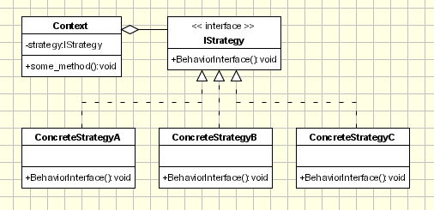

Ex:

Example - Robots Application
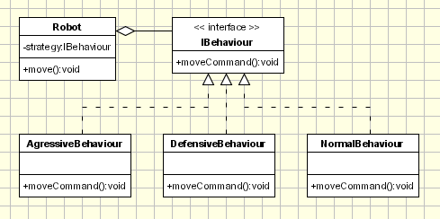
Let's consider an application used to simulate and study robots interaction. For the beginning a simple application is created to simulate an arena where robots are interacting. We have the following classes:
IBehaviour (Strategy) - an interface that defines the behavior of a robot
Conctete Strategies: AggressiveBehaviour, DefensiveBehaviour, NormalBehaviour; each of them defines a specific behavior. In order to decide the action this class needs information that is passed from robot sensors like position, close obstacles, etc.
Robot - The robot is the context class. It keeps or gets context information such as position, close obstacles, etc, and passes necessary information to the Strategy class.
In the main section of the application the several robots are created and several different behaviors are created. Each robot has a different behavior assigned: 'Big Robot' is an aggressive one and attacks any other robot found, 'George v.2.1' is really scared and run away in the opposite direction when it encounter another robot and 'R2' is pretty calm and ignore any other robot. At some point the behaviors are changed for each robot.
public interface IBehaviour {
public int moveCommand();
}
public class AgressiveBehaviour implements IBehaviour{
public int moveCommand()
{
System.out.println("\tAgressive Behaviour: if find another robot attack it");
return 1;
}
}
public class DefensiveBehaviour implements IBehaviour{
public int moveCommand()
{
System.out.println("\tDefensive Behaviour: if find another robot run from it");
return -1;
}
}
public class NormalBehaviour implements IBehaviour{
public int moveCommand()
{
System.out.println("\tNormal Behaviour: if find another robot ignore it");
return 0;
}
}
public class Robot {
IBehaviour behaviour;
String name;
public Robot(String name)
{
this.name = name;
}
public void setBehaviour(IBehaviour behaviour)
{
this.behaviour = behaviour;
}
public IBehaviour getBehaviour()
{
return behaviour;
}
public void move()
{
System.out.println(this.name + ": Based on current position" +
"the behaviour object decide the next move:");
int command = behaviour.moveCommand();
// ... send the command to mechanisms
System.out.println("\tThe result returned by behaviour object " +
"is sent to the movement mechanisms " +
" for the robot '" + this.name + "'");
}
public String getName() {
return name;
}
public void setName(String name) {
this.name = name;
}
}
public class Main {
public static void main(String[] args) {
Robot r1 = new Robot("Big Robot");
Robot r2 = new Robot("George v.2.1");
Robot r3 = new Robot("R2");
r1.setBehaviour(new AgressiveBehaviour());
r2.setBehaviour(new DefensiveBehaviour());
r3.setBehaviour(new NormalBehaviour());
r1.move();
r2.move();
r3.move();
System.out.println("\r\nNew behaviours: " +
"\r\n\t'Big Robot' gets really scared" +
"\r\n\t, 'George v.2.1' becomes really mad because" +
"it's always attacked by other robots" +
"\r\n\t and R2 keeps its calm\r\n");
r1.setBehaviour(new DefensiveBehaviour());
r2.setBehaviour(new AgressiveBehaviour());
r1.move();
r2.move();
r3.move();
}
}

State vs. Strategy
State is often confused with its close cousin Strategy, and it is sometimes difficult to determine which pattern to use, or if an implementation of one is actually the other. A good rule of thumb to follow to distinguish the two is that if the Context will contain only one (of several possible) �State� or �Strategy� objects during its lifetime, you are probably using the Strategy pattern. If, on the other hand, the Context changes during the normal course of an application so that, over time, it may contain many different �state� objects , then you may be referring to a State implementation, particularly if there are well-defined orders of transition between the different states.

A subtler distinction can sometimes be found in the setting of an object�s attributes. An object is usually put into a state by an external client, while it will choose a strategy on its own.
Another distinction is that a Context seems to hide the Strategy it�s using, but the State it�s using is quite apparent to its Client. For example, when a Client tells a Storage-Device to store some text, the device may use one of several different techniques to compress the text before storing it, including no compression at all. However, the Client doesn�t care how the device compresses the text, whether it does so at all, or whether it compresses the text the same way every time. It just wants the device to store and retrieve the text on command. Because of the way the compression is private to the device and hidden from the Client, the different compression objects are Strategies. On the other hand, once a Client opens a TCPConnection, it certainly expects the connection to behave like it�s open. Once the Client closes the connection, it expected the connected to act like it�s closed. Because the connection�s status is readily apparent to the Client, the status objects are States.

- Iterator Pattern
Provides a way to traverse through the collection of objects sequentially without exposing its underlying representation.

Ex: Using Iterator in java.

- Mediator Pattern
This pattern is used to simplify the interaction between different objects involved in a complex system. This can be accomplished by having a mediator class which will is registered with all other objects, and it will in turn communicate with different objects as what needs to be done.

Ex: In a GUI where the interaction between different button,text fields and list is need to be done.

- Observer Pattern
Defines one to many relationship between objects so that when one object is changed other dependent objects are updated and notified accordingly.

Ex: Changes in data needs to be informed for displaying in list and also in graph

Visitor Pattern
visitor design pattern is a way of separating an algorithm from an object structure it operates on. A practical result of this separation is the ability to add new operations to existing object structures without modifying those structures.

Motivation
Collections are data types widely used in object oriented programming. Often collections contain objects of different types and in those cases some operations have to be performed on all the collection elements without knowing the type.
A possible approach to apply a specific operation on objects of different types in a collection would be the use if blocks in conjunction with 'instanceof' for each element. This approach is not a nice one, not flexible and not object oriented at all. At this point we should think to the Open Close principle and we should remember from there that we can replace if blocks with an abstract class and each concrete class will implement its own operation.

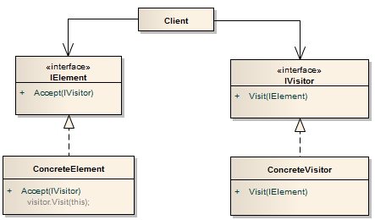

Example 1 - Customers Application.
We want to create a reporting module in our application to make statistics about a group of customers. The statistics should made very detailed so all the data related to the customer must be parsed. All the entities involved in this hierarchy must accept a visitor so the CustomerGroup, Customer, Order and Item are visitable objects.

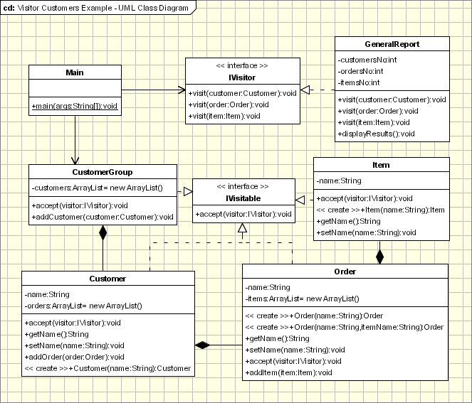
Main.java - The Main class is the client object. It has a reference tot the Object structure. In our case the objects Structure is the Customers objects
package com.oodesign.designpatterns.behavioral.visitor.impl;
package com.oodesign.designpatterns.behavioral.visitor.customers;
public class Main {
/**
* @param args
*/
public static void main(String[] args) {
// TODO Auto-generated method stub
Customer c = new Customer("customer1");
c.addOrder(new Order(".order1", "..item1"));
c.addOrder(new Order(".order2", "..item1"));
c.addOrder(new Order(".order3", "..item1"));
Customer c2 = new Customer("customer2");
Order o = new Order(".order_a");
o.addItem(new Item("..item_a1"));
o.addItem(new Item("..item_a2"));
o.addItem(new Item("..item_a3"));
c2.addOrder(o);
c2.addOrder(new Order(".order_b", "..item_b1"));
CustomerGroup customers = new CustomerGroup();
customers.addCustomer(c);
customers.addCustomer(c2);
GeneralReport visitor = new GeneralReport();
customers.accept(visitor);
visitor.displayResults();
}
}
IVisitor and IVisitable interfaces
package com.oodesign.designpatterns.behavioral.visitor.customers;
public interface IVisitable {
public void accept(IVisitor visitor);
}

package com.oodesign.designpatterns.behavioral.visitor.customers;
public interface IVisitor {
public void visit(Customer customer);
public void visit(Order order);
public void visit(Item item);
}

GeneralReport is a visitor class and implements the IVisitor interface. Other Visitors (other reports or other types of visitors) can be added by implementing the IVisitor interface

package com.oodesign.designpatterns.behavioral.visitor.customers;
public class GeneralReport implements IVisitor{
private int customersNo;
private int ordersNo;
private int itemsNo;
public void visit(Customer customer)
{
System.out.println(customer.getName());
customersNo ++;
}
public void visit(Order order)
{
System.out.println(order.getName());
ordersNo++;
}
public void visit(Item item)
{
System.out.println(item.getName());
itemsNo++;
}
public void displayResults()
{
System.out.println("Nr of customers:" + customersNo);
System.out.println("Nr of orders: " + ordersNo);
System.out.println("Nr of itemss: " + itemsNo);
}
}
CustomerGroup, Customer, Order and Item are all visitable classes. A CustomerGroup represents a group of customers, each Customer can have one or more orders and each order can have one ore more Items.

package com.oodesign.designpatterns.behavioral.visitor.customers;
import java.util.ArrayList;
import java.util.Iterator;
public class CustomerGroup {
private ArrayList customers = new ArrayList();
public void accept(IVisitor visitor)
{
for (Iterator it=customers.iterator(); it.hasNext();)
{
((Customer)it.next()).accept(visitor);
}
}
public void addCustomer(Customer customer)
{
customers.add(customer);
}
}

package com.oodesign.designpatterns.behavioral.visitor.customers;
import java.util.ArrayList;
import java.util.Iterator;
public class Customer implements IVisitable{
private String name;
private ArrayList orders = new ArrayList();
public void accept(IVisitor visitor)
{
visitor.visit(this);
for (Iterator it=orders.iterator(); it.hasNext();)
{
((IVisitable)it.next()).accept(visitor);
}
}
public String getName() {
return name;
}
public void setName(String name) {
this.name = name;
}
public void addOrder(Order order)
{
orders.add(order);
}
public Customer(String name)
{
this.name = name;
}
}

package com.oodesign.designpatterns.behavioral.visitor.customers;
import java.util.ArrayList;
import java.util.Iterator;
public class Order implements IVisitable {
private String name;
private ArrayList items = new ArrayList();
public Order(String name)
{
this.name = name;
}
public Order(String name, String itemName)
{
this.name = name;
this.addItem(new Item(itemName));
}
public String getName() {
return name;
}
public void setName(String name) {
this.name = name;
}
public void accept(IVisitor visitor)
{
visitor.visit(this);
for (Iterator it=items.iterator(); it.hasNext();)
{
((Item)it.next()).accept(visitor);
}
}
public void addItem(Item item)
{
items.add(item);
}
}

package com.oodesign.designpatterns.behavioral.visitor.customers;
public class Item implements IVisitable{
private String name;
public void accept(IVisitor visitor)
{
visitor.visit(this);
}
public Item(String name)
{
this.name = name;
}
public String getName() {
return name;
}
public void setName(String name) {
this.name = name;
}
}

Template Method Pattern

The Template Method defines a skeleton of an algorithm in an operation, and defers some steps to subclasses

Example - Application used by a travel agency.
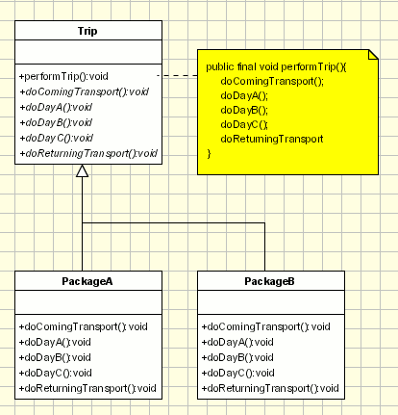
Lets' assume we have to develop an application for a travel agency. The travel agency is managing each trip. All the trips contain common behavior but there are several packages. For example each trip contains the basic steps:
- The tourists are transported to the holiday location by plane/train/ships,...
- Each day they are visiting something
- They are returning back home.
So we create an abstract class containing each step as an abstract method and one concrete and final method that calls all the abstracts methods. Then we create one superclass for each package:
public class Trip {
public final void performTrip(){
doComingTransport();
doDayA();
doDayB();
doDayC();
doReturningTransport
}
public abstract void doComingTransport();
public abstract void doDayA();
public abstract void doDayB();
public abstract void doDayC();
public abstract void doReturningTransport();
}
public class PackageA extends Trip {
public void doComingTransport() {
System.out.println("The turists are comming by air ...");
}
public void doDayA() {
System.out.println("The turists are visiting the aquarium ...");
}
public void doDayB() {
System.out.println("The turists are going to the beach ...");
}
public void doDayC() {
System.out.println("The turists are going to mountains ...");
}
public void doReturningTransport() {
System.out.println("The turists are going home by air ...");
}
}
public class PackageB extends Trip {
public void doComingTransport() {
System.out.println("The turists are comming by train ...");
}
public void doDayA() {
System.out.println("The turists are visiting the mountain ...");
}
public void doDayB() {
System.out.println("The turists are going to the beach ...");
}
public void doDayC() {
System.out.println("The turists are going to zoo ...");
}
public void doReturningTransport() {
System.out.println("The turists are going home by train ...");
}
}

J2EE Patterns

J2EE Patterns can be broadly classified into
- Integration Tier Pattern
- Business Tier Pattern
- Presentation Tier Pattern

Integration Tier Pattern
- DataAccessObject Pattern
DAO pattern is used to abstract and encapsulate all accesses to the persistent storage. It manages the connection to persistent, obtain and store data.

Advanatge:
- Code reusability.
- It will be easier to change from BMP to CMP
- If the business logic changes db logic is not affected.

- Service Activatior Pattern
This pattern is used for asynchronous processing of messages by EJB in EJB’s before 2.0 version.

Business Tier Patterns
- The ValueObject Pattern
Entity beans contain attributes that are exposed to the client using get methds. As the client repeatedly calls the get method for each attribute it increases the network traffic. The get method becomes an inefficient way to obtain data from an entity bean. So if the client needs more than one attribute value from entity bean he has to make so many calls to the entity that increases the network traffic.

The solution is to use a ValueObject to encapsulate all entity data. When the client makes a call to the entity bean it encapsulates all data in a valueObject and passes it by value to the client using serialization.

- The ValueObjectAssembler Pattern
The client requires to know about the model to present it to the user or do something before offering the service to the user. For this we have to use session bean to build the required model or sub-model as value objects pulling the data from a set of entity beans that define the model or sub-model. This solution proposes that any such on the fly construction of the model be performed by the server and not the client.

- The SessionFacade Pattern
The session façade provides a way for abstracting the underlying interaction between different Business Objects and provides a service layer that exposes only the required interfaces to the client.
In this the Session bean takes up the responsibility of lookup, creating, modifying and deleting the participants as required by the workflow.

- ValueListHandler Pattern
This pattern tells us to use the session bean to execute a query which returns large amount of data (in place of finder method on the entity beans), cache the result and provide the result as needed by the client in a result set size that the client wants. The session bean should also provide previous and next functionality.

- The Aggregate Entity Pattern
This pattern tells us to use a single Aggregate entity bean to model and manage a set of interrelated persistent objects, instead of representing them as a number of fine grained entity beans. An agreegate entity bean represenst a tree of objects.

- The Service Locator Pattern
  - The Service locator object abstract and encapsulates all JNDI usage
  - Hides initial context creation, EJB Home creation, EJB Object creation
  - Provides a single point of contact for all clients
  - Improves performance by providing caching facility.

- The Business Delegate Pattern
Use a BusinessDelegate to handle the interaction between the client and the business services. Thus shielding the client from complex implementation details of the business service. BusinessDelegate should take care of the lookup and access details of EJB.

Presentation Tier Patterns

- FrontController Pattern
  - FrontController is used as first point of contact for processing all requests.
  - FrontController services include
    - security check,
    - authorization,
    - calling the specific business sevice components,
    - choosing an appropriate view and
    - error handler,
    - selecting content creation strategies and
    - preparing the model for use by the view to which it dispatches.

b, View Helper Component
Business logic is factored out of view into ViewHelper Component.

- CompositeView Pattern
This is based on inclusion and substitution of modular dynamic and static template fragments.

- Dispatch View Pattern
- Service to Worker Pattern

Session Facade
It is a design pattern in which the entity beans are accessed through local interfaces then accessed directly. This gives good performance.

Session Façade
Advantages
- Transaction control at one single place
- Loose coupling
- Bandwidth control
- Easy maintenance.

Lazy loading
Only primary bean wakes up when you try to invoke any method on that.

Aggressive loading
In this case all dependent beans will also get loaded into the memory.

Fine grained entity bean
We make specific calls to get specific data

Coarse grained entity bean
In this the calls return value Obects.

Business Delegate Pattern
This is a layer in between session façade and the servlet. This will take care of delegating the request from the servlet and calling appropriate ejb’s.

It does the caching of all shared data
Hide the details about which ejb’s are called and how.

Service locator Pattern
This does the implementation details for doing JNDI lookup and returning ejb object at one single place.

Advantages:
Caches the EJB Home object which improves the overall performance of the application.
Need to invoke the methods at single place to get the EJB Home, so better maintainance.

Value List Handler Pattern
The application server rather than returning huge amount of data to webserver returns small chunk of data at a time and keep the rest in stateful session bean.

- Prevents choking of the bandwidth between application server and webserver.
- Database access will be minimized because of caching.
- Prevents the webserver from crashing because of huge amount of data in Session.

Fast Lane Reader Pattern
Use the entity bean when it is absolutely needed otherwise for random data or for bulk data directly access the database through DAO.

Advantage:
Better performance.

Disadvantage:

DAO Pattern
All the JDBC code is put in separate layer rather than in session bean.

Advanatge:
- Code reusability.
- It will be easier to change from BMP to CMP
- If the business logic changes db logic is not affected.

